Y HOME SENSOR PCB

- PARTS:

QUANTITY: PARTS: NOMENCLATURE: LENGTH:

1 PER MACHINE 217045- PCB, BLANK, Y HOME SENSOR N/A

1 PER MACHINE 17672- HEADER, 10-PIN, RIGHT ANGLE N/A

1 PER MACHINE 17683- HEADER, STRAIGHT, 4-PIN, GOLDPLATE N/A

2 PER MACHINE 17550-2 HEADER, RIGHT ANGLE, 2-PIN N/A

1 PER MACHINE 10464- IC, -26LS31, 4-CHANNEL N/A

1 PER MACHINE 13520- CAP, CERAMIC, .1μF, 50V N/A

1 PER MACHINE 15332- RESISTOR, 220Ω, ¼W N/A

1 PER MACHINE 18457- SENSOR, PHOTOLOGIC N/A

- ASSEMBLY:

- INSERT AND SOLDER THE RESISTOR INTO ITS ASSIGNED PLACE, ACCORDING TO DIAGRAM 1.

- INSERT AND SOLDER THE IC (10464-) INTO ITS ASSIGNED PLACE, ACCORDING TO DIAGRAM 1.

- INSERT AND SOLDER THE CAPACITOR INTO ITS ASSIGNED PLACE, ACCORDING TO DIAGRAM 1.

- INSERT AND SOLDER THE TWO 2-PIN HEADERS INTO THEIR ASSIGNED PLACES, ACCORDING TO DIAGRAM 1.

E. INSERT AND SOLDER THE 10-PIN HEADER INTO PLACE, ACCORDING TO DIAGRAM 1.

- INSERT AND SOLDER THE SENSOR INTO ITS ASSIGNED PLACE, WITH THE WRITTEN-SIDE TOWARDS THE RESISTOR, ACCORDING TO DIAGRAM 1.

- INSERT AND SOLDER THE 4-PIN HEADER INTO PLACE, ACCORDING TO DIAGRAM 1.

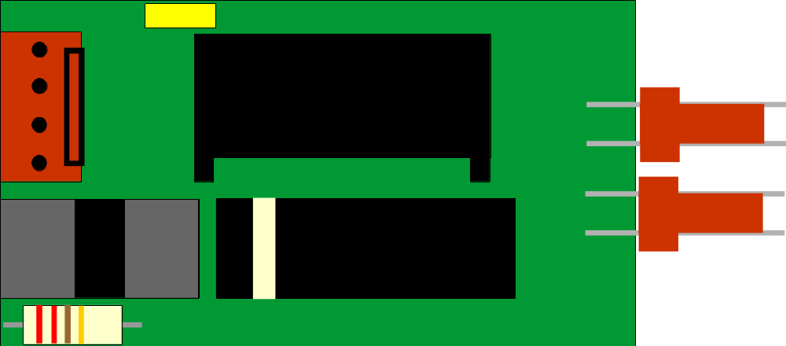

DIAGRAM 1

